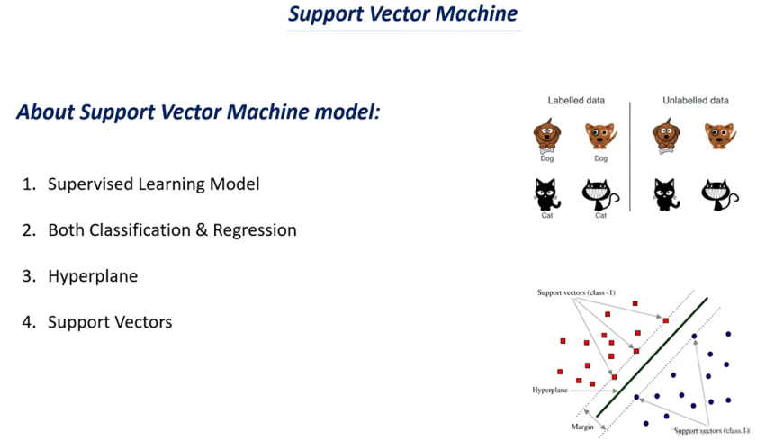

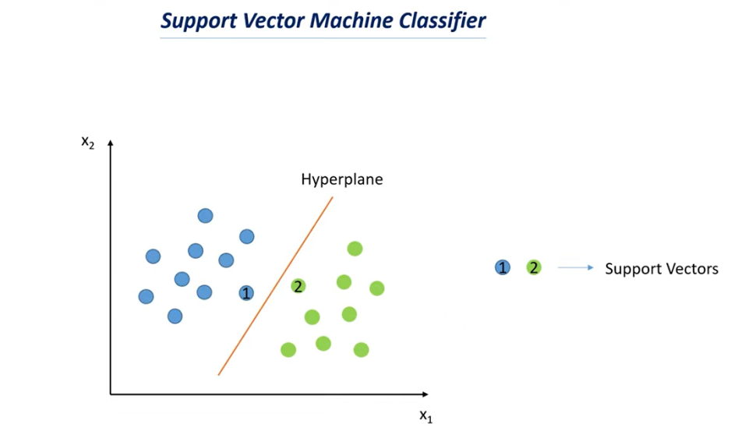

* Let’s say that we have two features x1 & x2 and we need to classify the data points into two groups or two classes based on these two features.
* Suppose this is the plot of features and we can see there are two features.
* Now what support vector machine classifier tries to do is it tries to find the hyper plane that can separate these two data points.
* The line is called as hyper plane.
* If we give a new data point the support vector machine model will tries to find whether the data point lies in which group based on that it tells us what kind of class it belongs to.
* The data point 1 & 2 in above plot are called as support vector.
* The support vectors are nothing but the data points which are very close to the hyper plane.
* Or the nearest point to the hyper plane is called support vector.
* The position of the support vector changes then the position of the hyper plane also changes.

